**Project Design Phase-II**

**Data Flow Diagram & User Stories-CAR RESALE VALUE PREDICTOR**

|  |  |
| --- | --- |
| Date | 03 October 2022 |
| Team ID | PNT2022TMID19165 |
| Project Name | Project - xxx |
| Maximum Marks | 4 Marks |

**Data Flow Diagrams:**

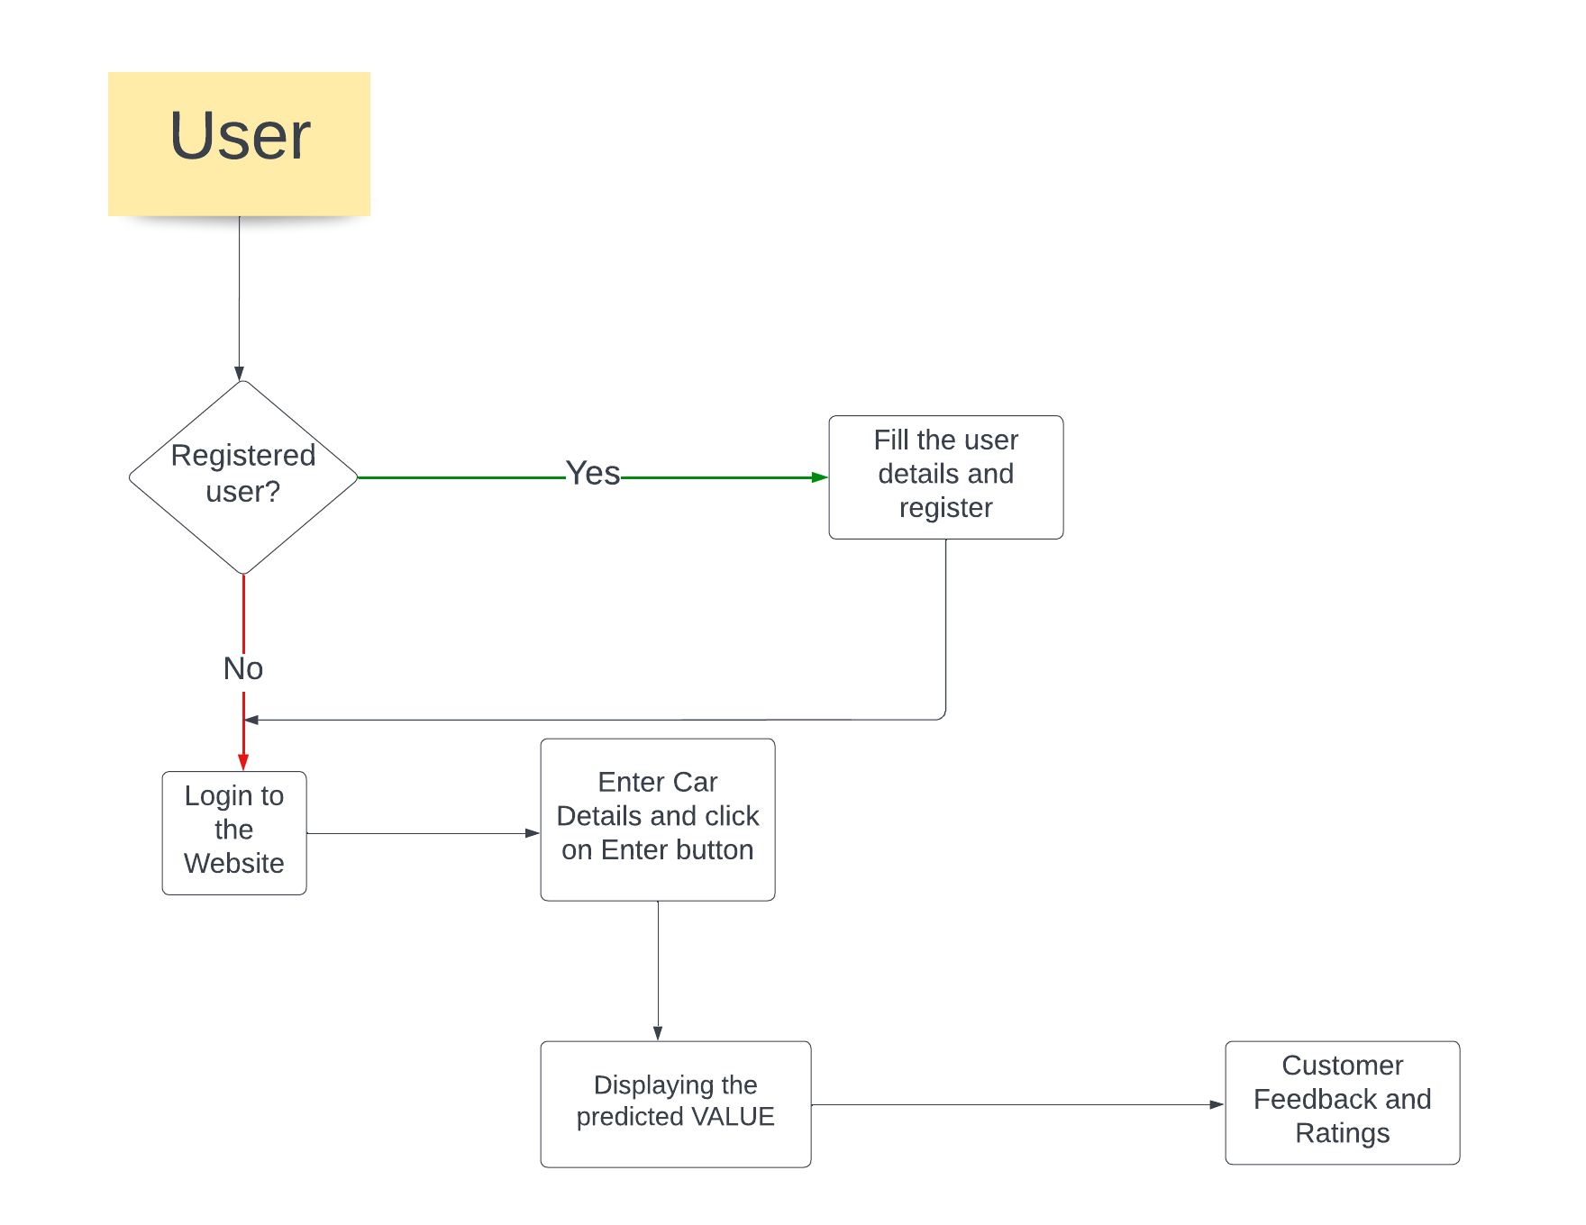

**User Stories**

User stories for the product.

| **User Type** | **Functional Requirement (Epic)** | **User Story Number** | **User Story / Task** | **Acceptance criteria** | **Priority** | **Release** |
| --- | --- | --- | --- | --- | --- | --- |
| Customer (Web user) | Web Browser | USN-1 | As a user, I can visit the website by entering my email, password, and confirming my password. | I can access my website by clicking on the link | High | Sprint-1 |
|  |  | USN-2 | I can move to home page | I can visit the website any number of time | Medium | Sprint-1 |
|  |  | USN-3 | We can move to the prediction page by clicking “predict” button. | I can get the result quickly. | High | Sprint-2 |
|  |  | USN-4 | Accurate value is shown in the webpage. | I can view the predicted value | High | Sprint-3 |
|  | Login | USN-5 | As a user, I can register to the application by entering email & password | Sign out is possible | High | Sprint-1 |
| Customer(Mobile App) | Mobile App(sign up) | USN-1 | As a user can register by filling user details. | Check correct format and proceed to the process. | High | Spring-5 |
|  | (Sign in) | USN-2 | As a user can login by using username and password. | Check the details and enter into the page. | Medium | Spring-6 |
| Customer(Mobile User) | Dashboard | USN-3 | As a user,I can move to the dashboard after login | Without further delay I can move to the Home page easily | Medium | Spring-6 |
|  |  | USN-4 | Enter Car Details | Car details is checked and moved to the model for value prediction. | Medium | Spring-6 |
|  |  | USN-5 | After entering Car Details click on Predict Value. | I can get the result without any delay. | High | Spring-6 |
|  |  |  |  |  |  |  |
|  |  |  |  |  |  |  |